Abstract ID (for office use only):

[Please mention theme of the conference as given in conference website]

**Title of the Paper**

Presenting Author1, 2, 3, Author 11,, Author 21, 2, Author 32….. Author 8 1, 2*

*1Department of ABC Engineering, Institute Name, City, State, Pincode, Country*

* Dr. MMC; Email: mmc@iitbhu.ac.in; Phone: (Country code) Numer

**Note:** Please underline the name of the presenting author; No author limitation for paper submission

**Abstract**

Please write an abstract within 200-300 words only

Keywords: [Not more than 5 key words]

1

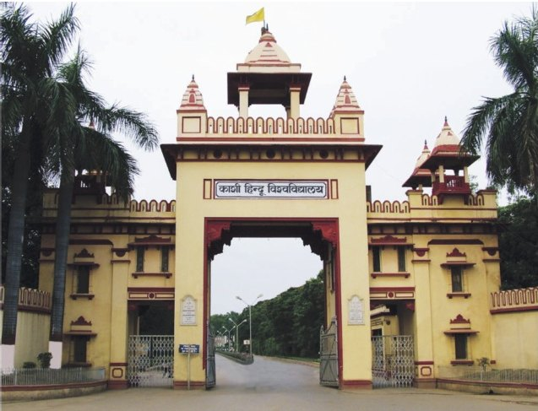

Figure 1: Description of figures…………………

References:

2